# **Project LegoLogic: Using Lego Spike Prime to Teach Essential Coding Concepts**

# 

**Abstract:** This study investigates the effectiveness of introducing essential coding concepts to young learners using the LEGO Spike Prime system within a hands-on workshop setting. The project’s approach leverages interactive and accessible tools to simplify the learning process of fundamental programming concepts, including loops, conditionals, and variables. Targeted at students in grades 6 and above with minimal programming experience, the workshop aims to foster interest in technology by providing participants with an opportunity to build and program dynamic models, such as a catapult, using drag-and-drop block coding. By employing pre- and post-surveys, the study assesses participant learning outcomes, exploring whether the playful, collaborative experience effectively supports foundational coding knowledge. Findings will be detailed in an accompanying poster, which will showcase learning results and engagement levels observed throughout the workshop.

# **Introduction**

# Technology has become an integral part of everyday life, and understanding its principles is essential in today’s world. However, introducing complex topics like programming to young learners can be challenging. By using accessible and interactive tools, such as the LEGO Spike Prime system, we can make learning coding both engaging and fun for students.

This project introduces essential coding concepts through a hands-on workshop in which participants build and program models. Through this playful approach, we hypothesize that students will learn fundamental programming skills like loops, conditionals, and variables, gaining a solid foundation in coding and robotics. We will study whether we reach our target by surveying participants’ knowledge in these workshops.

**Study Target**

This study is geared toward students in grades 6 and above who have minimal programming experience. This project aims to engage young students and spark their interest in technology at an early age. By teaching essential programming concepts through the interactive and playful use of LEGO Spike, the study aims to make learning coding both simple and enjoyable. The project also seeks to encourage collaboration among the participants with a fun, hands-on activity where students can create and play a game while gaining foundational coding knowledge.

# **Description of TAP program**

# The Technology Ambassadors Program (TAP) was created to spark an interest in information technology within the community using fun and interactive technology workshops [1]. TAP aims to engage a broad audience by developing projects that are simple enough to be understood by a wide range of participants, including both those with prior knowledge of information technology and complete beginners. This approach ensures that the program is accessible and appealing to people with varying levels of experience.

# **Methods**

The project utilizes the LEGO Spike set [3] along with the LEGO Spike Word Block coding platform [2]. The LEGO Spike set includes various components such as motors and color sensors, which are essential for building interactive and dynamic models. The motors allow for movement and mechanical functionality, while the color sensors enable the detection of different colors, adding an element of responsiveness to the project. The LEGO Spike Word Block coding platform provides an intuitive drag-and-drop block coding interface, making it easy for beginners to learn and apply coding concepts without needing prior programming experience.

Through this project, the aim is to teach essential coding concepts, including loops, variables, and conditionals by constructing a catapult-like contraption that can be aimed to throw projectiles [4,5]. Participants will learn to create simple loops, such as "repeat" or "while" loops, to control motors and automate repetitive tasks. Additionally, participants will grasp the concept of conditionals, like "if-else" statements, using them to make decisions within their programs. This will involve programming the machine to make choices based on sensor input or predefined conditions, such as turning the catapult to aim it based on light sensor input. And finally, participants will learn how to create and use variables to store and modify data, including counters or sensor readings, throughout their program. 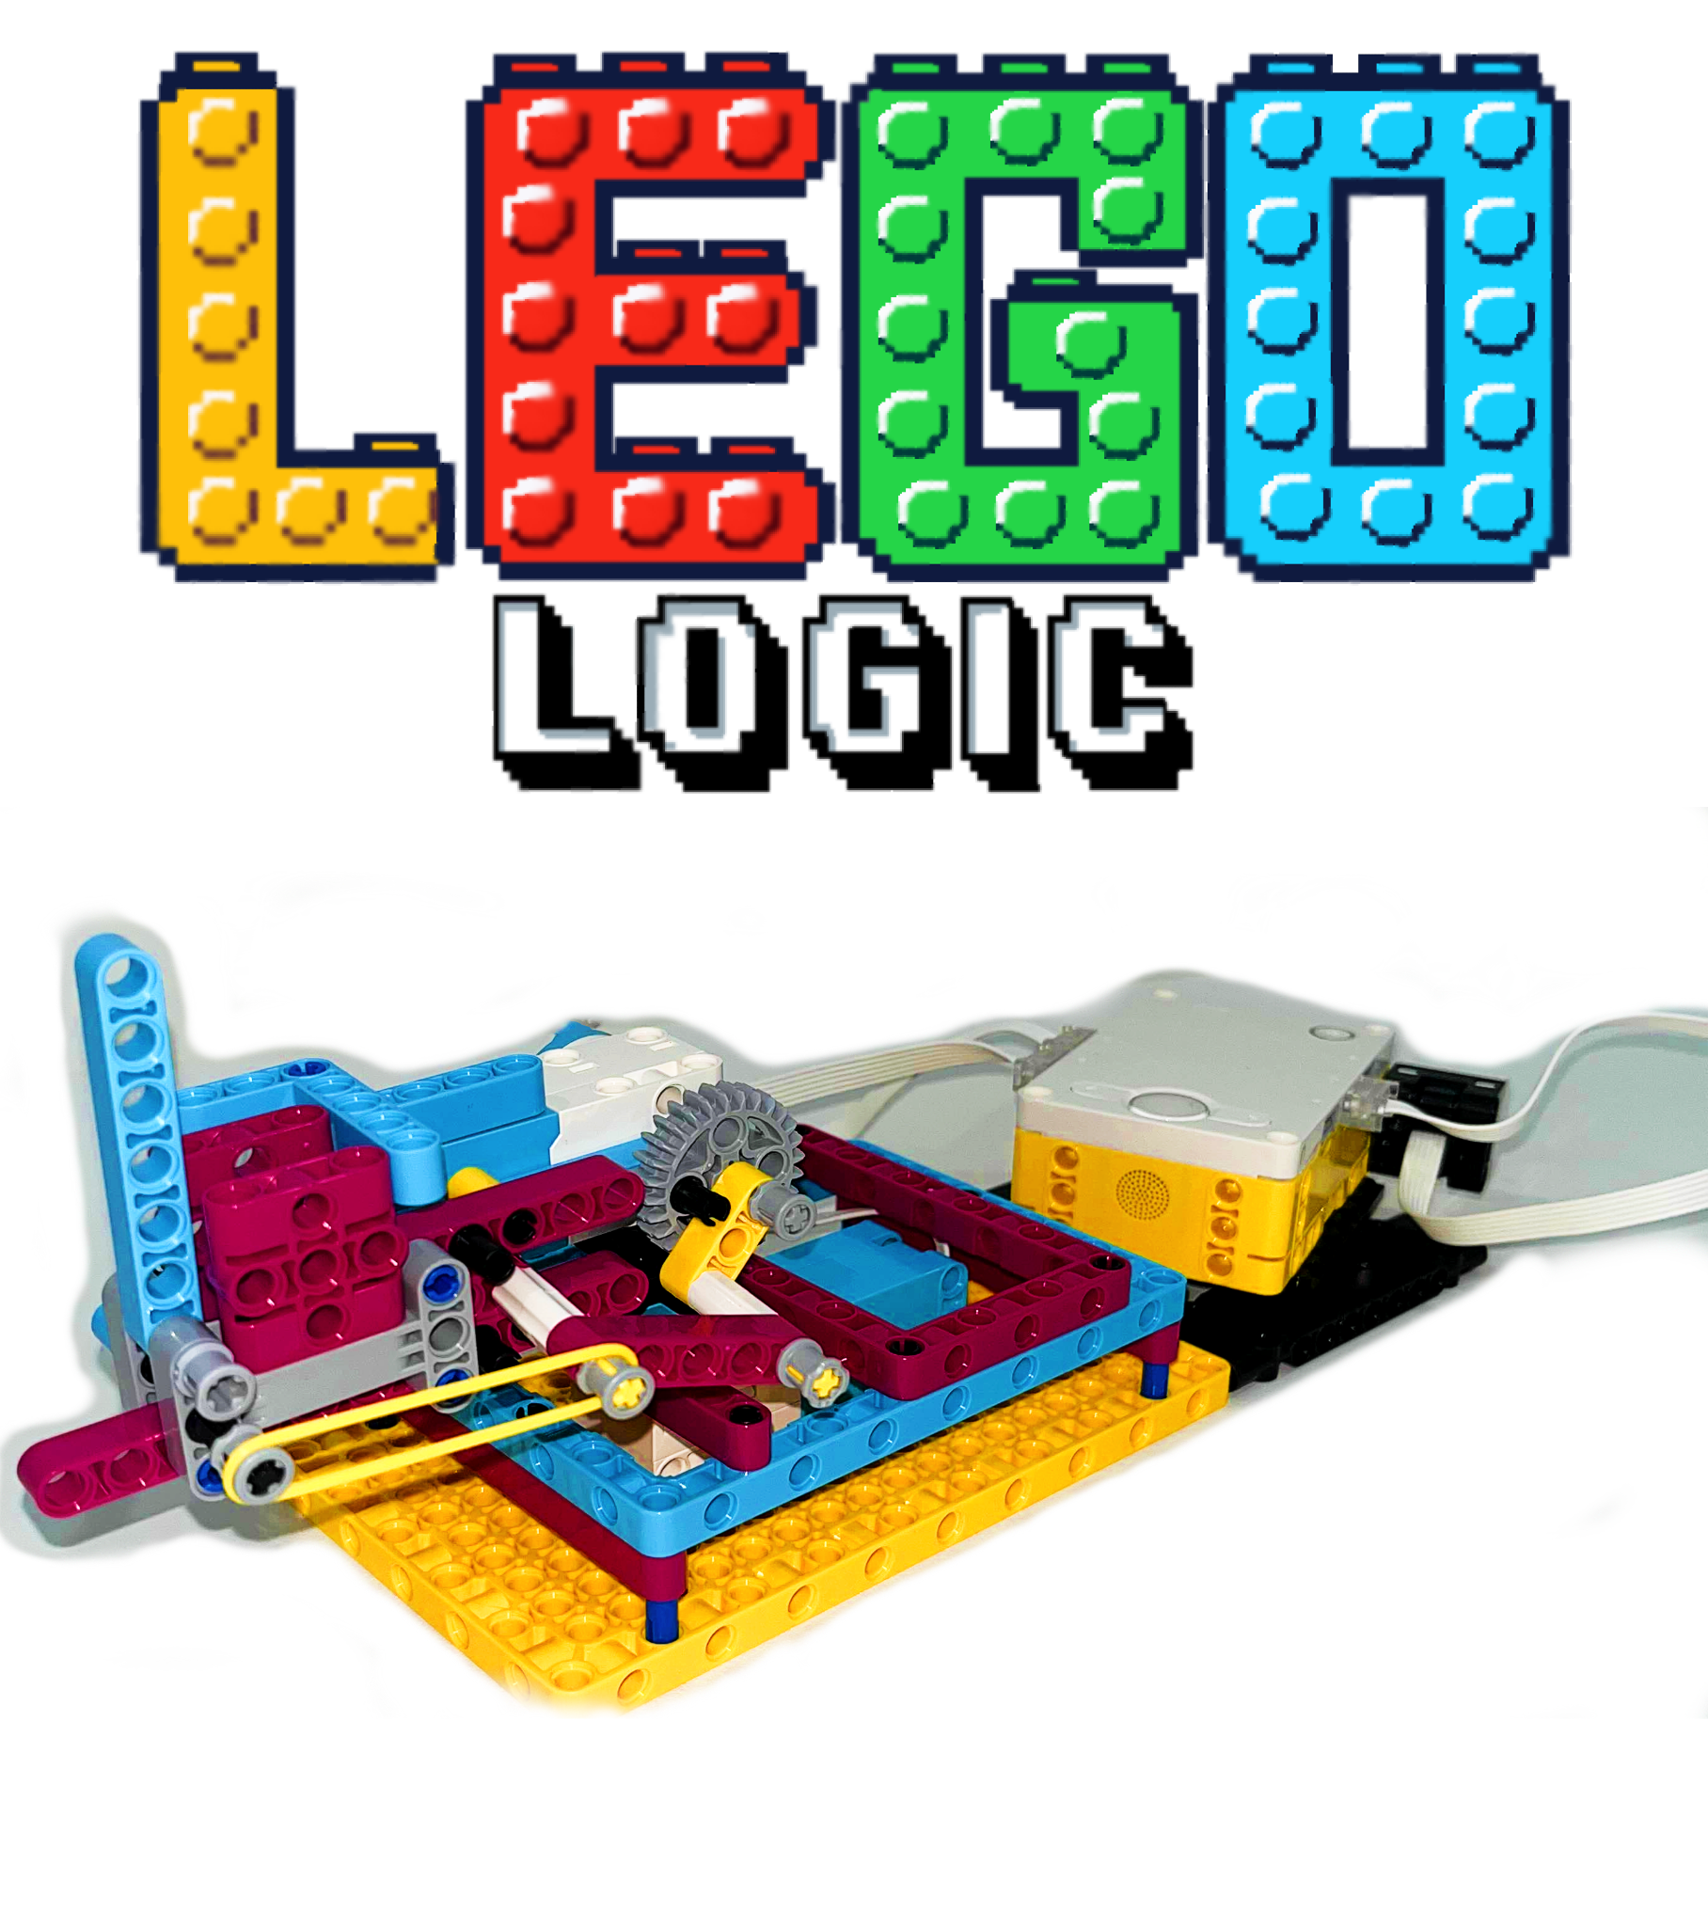

These fundamental concepts are the building blocks of programming, and by integrating them into a hands-on, interactive experience, the project makes learning engaging and accessible to students. We will conduct pre- and post-surveys to test the participants’ knowledge gained on these topics in the workshop to test whether our method has been effective.

**Figure 1.** Catapult object being constructed with the LEGO Spike set.

# **Results**

# 

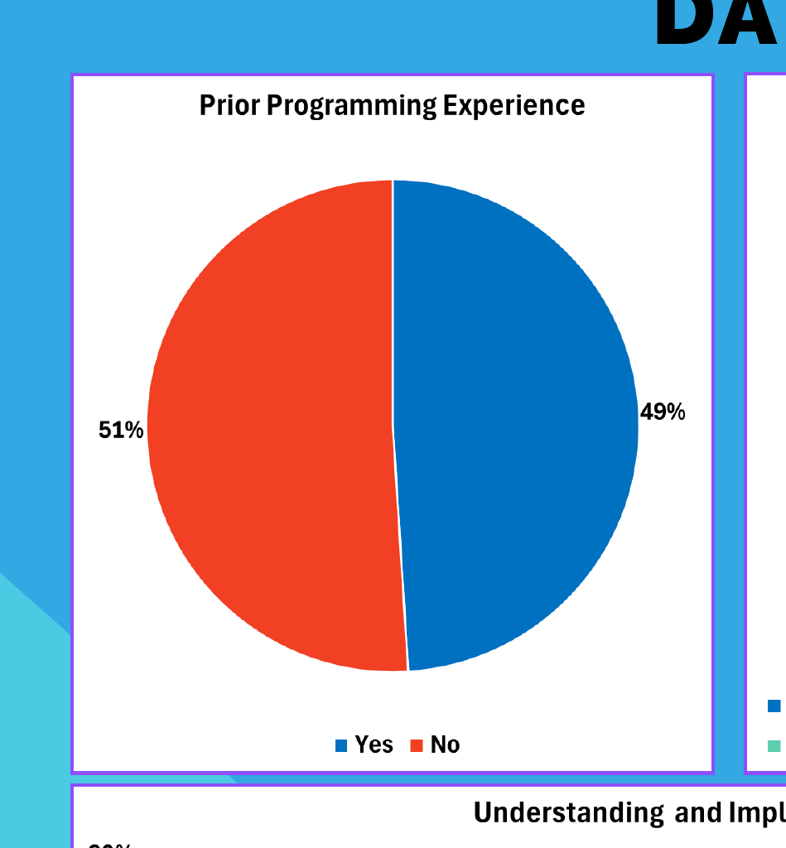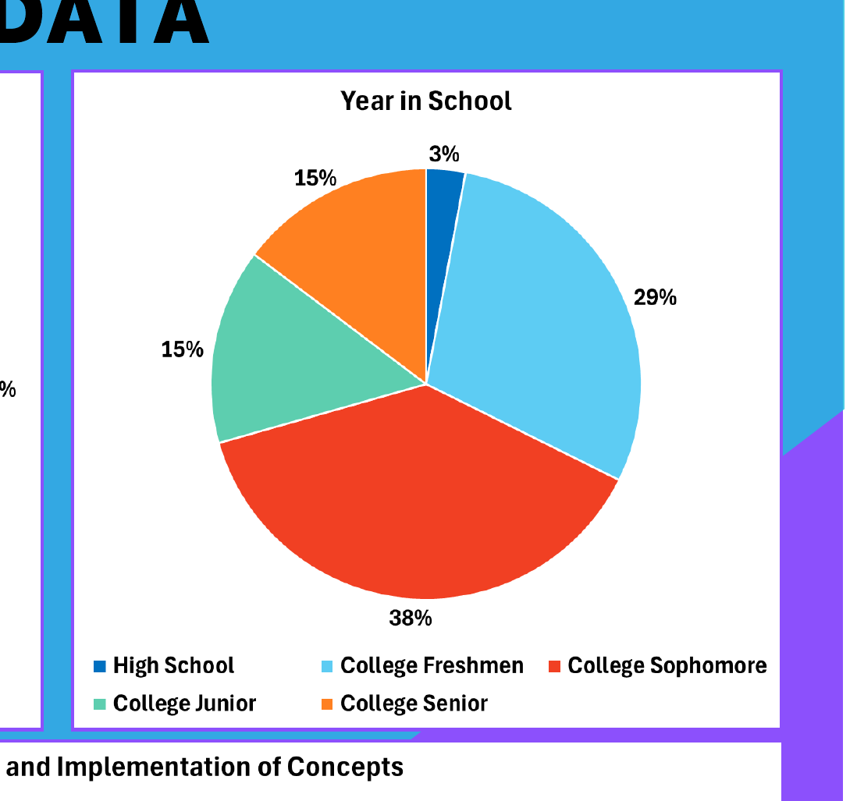

**Figure 2.** Graphical representation of participant demographics. The left chart shows participants' prior programming experience. The right pie chart displays participants' academic levels.

By the end of this LEGO Spike program lesson, participants will gain a foundational understanding of key programming concepts, including loops, conditionals, and variables, through the block coding provided by the LEGO Spike Prime system. The workshops were presented to students from beginner-level IT classes, resulting in a participant pool with different levels of programming experience. Students had various proficiency levels in basic coding concepts like variables and loops, and how to apply them.

**Figure 3.** Comparison of pre- and post-workshop scores in understanding and implementing programming concepts. The bar chart compares results across four key areas: understanding of variables, conditionals, and loops, and overall implementation of concepts.

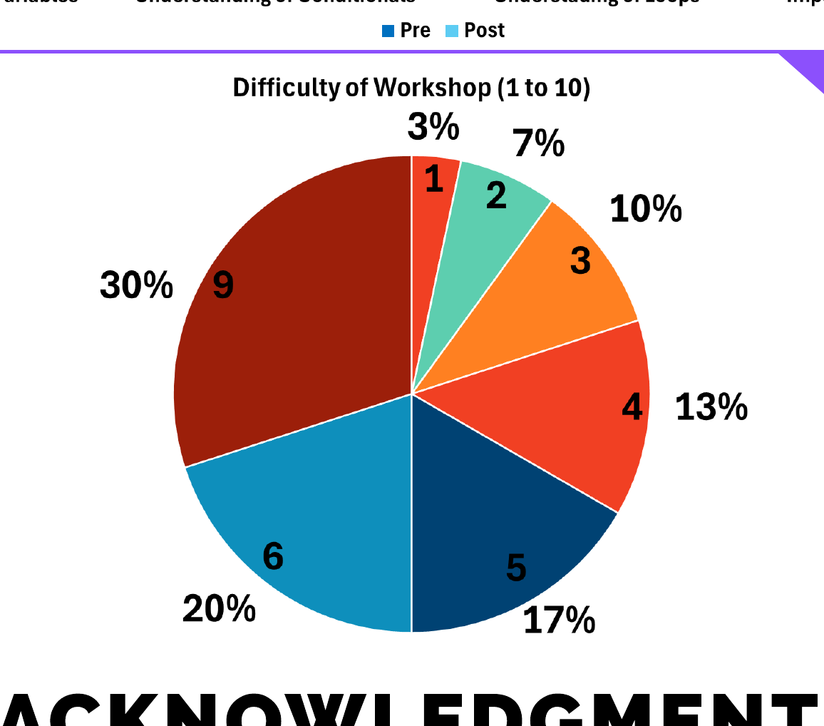

**Figure 4.** Participant ratings of workshop difficulty on a scale from 1(easiest) to 10(hardest).

Post-survey results, as seen in Figure 3, indicated an improved understanding of coding fundamentals, especially loops and conditionals. Participants found the workshop engaging and generally rated it as easy to follow, as represented in Figure 4. Hands-on activities were well-received, though some suggested adding more demonstrations and varied LEGO builds. Overall, the workshop effectively boosted foundational coding skills and increased interest in programming among attendees.

# **References**

[1] Dekhane, S., Xu, X., Napier, N., Barakat, R., Gunay, C., & Nagel, K. (2018). Technology focused service-learning course to increase confidence and persistence in computing. Journal of Computing Sciences in Colleges, 34(2), 147-153.  
<https://dl.acm.org/doi/10.5555/3282588.3282609>

[2] Körei, A., & Szilágyi, S. (2022). From Scratch to Python : Lego Robots AS motivational tools for coding. *Multidiszciplináris Tudományok*, *12*(3), 247–255. <https://doi.org/10.35925/j.multi.2022.3.22>

[3] *Lego Education Spike*, spike.legoeducation.com/prime/models/. Accessed 23 Sept. 2024.

[4] *Spike Prime “Automatic Lego Catapult”*. Joy coding : 네이버 블로그. (n.d.). https://blog.naver.com/subeen40/223234159558

[5] YouTube. (n.d.). *[Tutorial] The Ultimate LEGO Cannon Tutorial: Build, Aim, Fire!*. YouTube. <https://www.youtube.com/watch?v=2pB8OkP1ReM>

# **Acknowledgments**

# This project has been partially funded by the National Science Foundation grant #2315804. We would like to express our sincere gratitude to all those who contributed to the success of this project. We also extend our appreciation to the GGC Technology Ambassadors Program (TAP) faculty and students and the School of Science and Technology for providing the resources and platform for this project.